# Folder Creation using Python

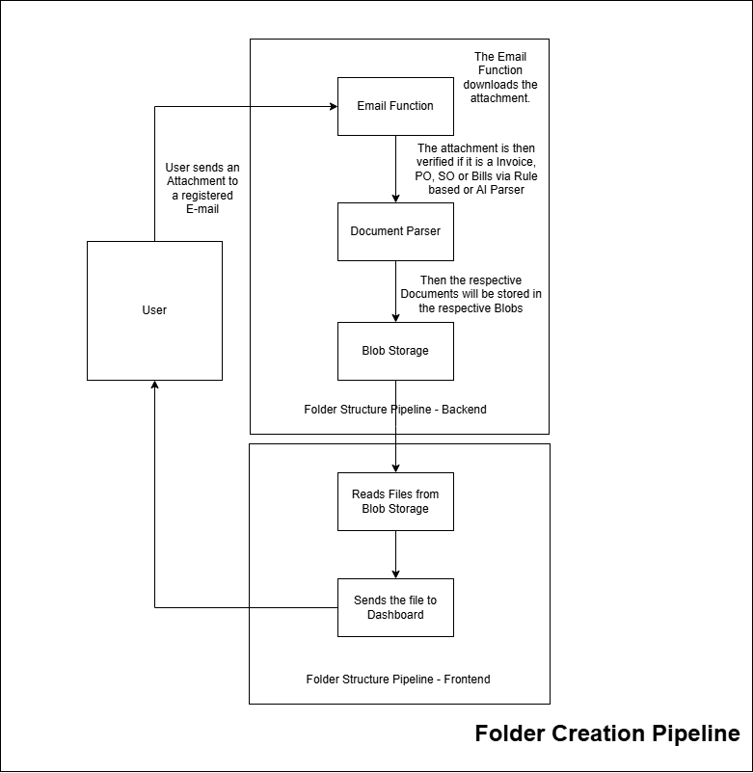

## Backend – SAP Code

The folder structure is as below

Sap_code

|── .env # Environmental files

|── Dockerfile # For containerization

|── app.py # FastAPI server Start Point

|── requirements.txt # Project Requirements

|── utils/

| |── blob_storage.py # Saving the documents to Azure Blob

| |── parser.py # Used to parse the documents

| |── send_email.py # Used to download attachments from email

## Process:

1. The user sends the Attachment to the registered E-mail
2. The Attachment would be downloaded via python code (which calls send_email.py).
3. The attachment would be next identified if it is a PO, SO, Bills or Invoice via Rule based methodology or Document AI Parser (parser.py)
4. Once the attachment is identified it will be stored in the Azure blob using blob_storage.py python file.

## Frontend – Streamlit Dashboard

The folder structure is as below

Sap_code

|── .env # Environmental files

|── Dockerfile # For containerization

|── app.py # Streamlit dashboard server Start Point

|── requirements.txt # Project Requirements

## Process:

1. The server fetches the data from Azure Blob storage.
2. The server displays it for a preview and user can rename the document.
3. Once the rename is done the user should click on the Mark as processed button to process that document.
4. After clicking on that button, the document will be moved to processed folder.

References

1. Frontend app: <https://streamlit-dashboard-v3-fcebchf3ewaeb0ec.canadacentral-01.azurewebsites.net/>
2. Frontend Webapp link: https://portal.azure.com/#@nsight-inc.com/resource/subscriptions/1b19d572-31bd-4b28-b0ca-69fe8a281bb5/resourcegroups/Docai_parsers/providers/Microsoft.Web/sites/streamlit-dashboard-app/appServices
3. Backend app: sapjsonv2.bfdufghgcnfhc3ee.eastus.azurecontainer.io
4. Backend Container Path: <https://portal.azure.com/#@nsight-inc.com/resource/subscriptions/1b19d572-31bd-4b28-b0ca-69fe8a281bb5/resourceGroups/Docai_parsers/providers/Microsoft.ContainerInstance/containerGroups/sapjsonv2/overview>